**Cover Page**

**COMPSCI 345 / SOFTENG 350 Human-Computer Interaction**

**Assignment Three: Realizing a Design**

**Student Name:** Seung Min Lee

**Student ID: 8078435**

**Student UPI: Slee828**

____________________________________________________________________

Note: To ensure a fair playing field for all students in the class the University of Auckland will not tolerate cheating or assisting others to cheat, and views cheating in coursework as a serious academic offence.

Student Declaration:

* I declare that this work is my own work and reflects my own learning.
* I declare that where work from other sources (including sources on the world-wide web) has been used, it has been properly acknowledged and referenced.
* I understand that my assessed work may be reviewed against electronic source material using computerised detection mechanisms.

Place this page in the front as the first page of your document that you are submitting to Canvas

Walkthrough:

Scenario 1:

*Brief explanation:*

Phani wants to find articles relating to strength training in rugby. First thing Phani does is read the main page to get an idea of the website. Since Phani is not tech savvy he asks teacher for help and they ask him to perform a few task on the website. From the website (after he login) he goes to the archives tab and scrolls through the many articles regarding strength training, in particular, articles that are aimed towards improving strength in rugby. Finally Phani is then asked to look at calendar widget to check his schedule and to see when his homework is due (set by the teacher). At this point he feels comfortable using the system and after reading the relevant material he attempts to answer the questions regarding a particular article he was reading. He then goes to the forums tab and will answer the questions there. Afterwards other member of his group can provide feedback on his answers.

1. Accessing the main page:

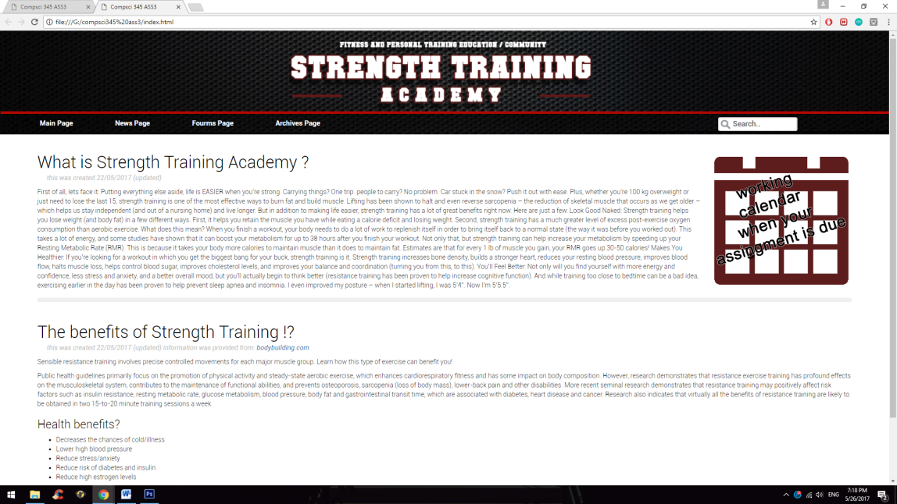

1. Accessing the Archive to read about strength training:

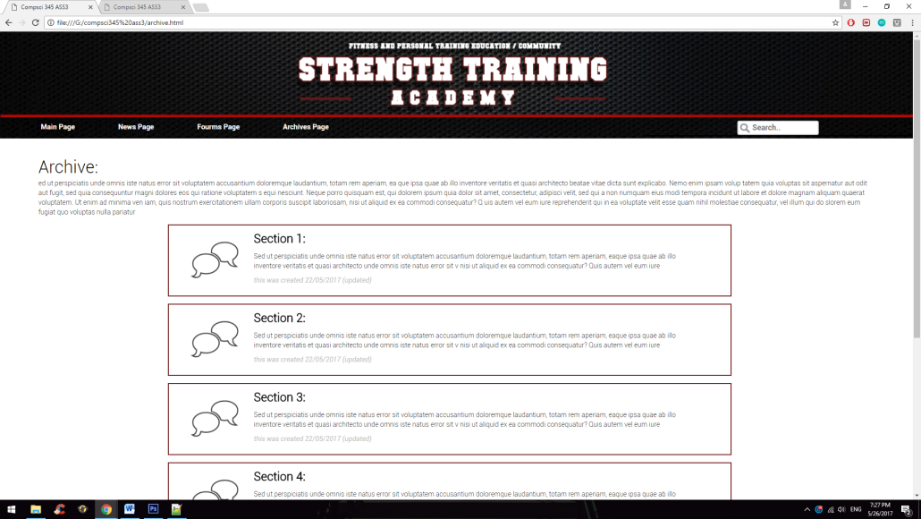

Each section will be named differently; example ‘Section 1’, will have a proper name in the actual design ‘just a place holder’

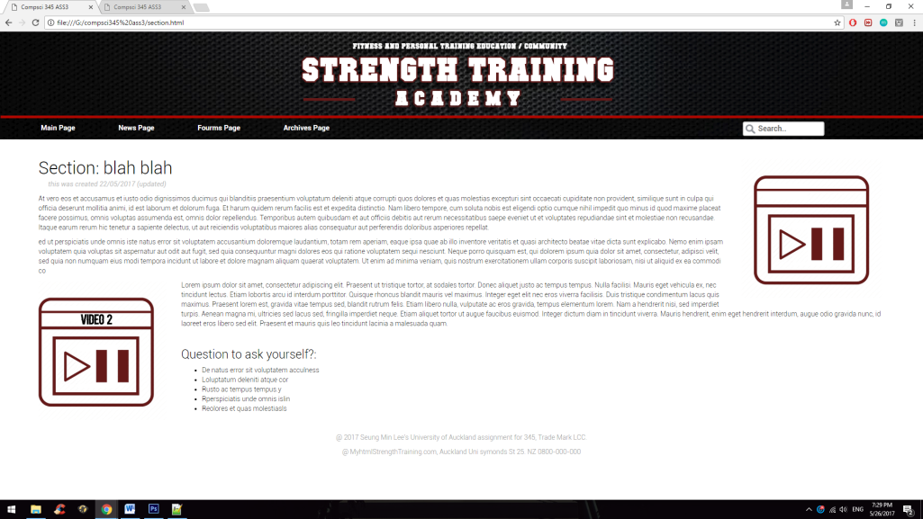

When the user click on one of the section, which would show information regarding ‘strength training’ (each section has different topics on strength training.) It will give in-depth explanation on how this section of the strength training is done and will also have videos to show the practical use of the information.